**Key Stage 3 History Trail**

**Take a journey through the core skills of the History National Curriculum as you explore the Roman Baths. This trail should take you about one hour to complete. Key the number into your handset whenever you see this icon.** A black and white symbol

**Good luck!**

**‘The Terrace’ – Chronology**

* **85** At the end of which century were the Roman Baths re-discovered? _______
* **29** What types of people are represented by the statues on the terrace?

____________________________________________________________

Why do you think they have been chosen? ________________________________________________________________________________________________________________________

* **27** Where did the water come from originally? _________________________

**‘Meet the Romans’ – Change and Continuity**

Watch the introductory video and describe the people who would have visited the baths and temple:________________________________________________________

* **16** What is the name of the goddess? Where does her name come from?

When did the Romans successfully invade Britian? ____________________

Compare the clear perspex model of the Baths in the First Century with the model of the Baths in the Fourth Century.

|  |
| --- |
| List all the CHANGES that you can see: |

|  |
| --- |
| List all the CONTINUITIES (SIMILARITIES) that you can see: |

Now take a seat in front of the Temple pediment. At the centre of the pediment is a Gorgon. These creatures came from Ancient Greek myth. This one, however, is different from how the Greeks normally depicted them. Compare the Gorgon on the pediment with the picture below. How does the Bath Gorgon differ from usual Gorgons? Make a list of the differences on the lines below the picture.

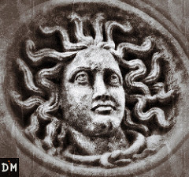

Differences: _________________________________________________________________

_________________________________________________________________

* **65** The commentary discusses two interpretations of the images on the pediment. What are they?

_________________________________________________________________

_________________________________________________________________

List the main symbols of Sulis Minerva that feature on the pediment.

__________________________________________________________________________________________________________________________________________________

Make a sketch of the pediment here:

**Interpretation – Part 1**

Listen to these audio commentaries about the Gorgon’s Head pediment. How do each of these people educate and inform their audiences? How are their audiences different? Fill in the table below.

|  |  |  |
| --- | --- | --- |
| Audio Commentary **65** | Audio Commentary **175** | Audio Commentary **55** |
| Narrated by voice actor, main narrator for audio tour | Narrated by Michael Rosen, children’s author | Narrated by Zosia Matyjaszkiewicz, Roman Baths Collection Manager |
| Mic and audio filter |  |  |
| Audience:  General visitors to the Roman Baths | Audience:  Children | Audience:  Adults who want more in depth facts |
| They appeal to  their audience by… | He appeals to his audience by… | She appeals to her audience by… |

**‘Life and Death in Aquae Sulis’ – Using Evidence**

Find and stand in front of the glass case containing the full-size human skeleton.

* **108 & 26** What evidence do archaeologists have for each of the following?

The person being wealthy ____________________________________________

The diet of the person whilst alive ______________________________________

The person being from Syria __________________________________________

What aspects of the skeleton can archaeologists not explain?

_________________________________________________________________

* **26** Lots of people travelled great distances to visit Aquae Sulis. Using the audio, objects and labels, find out where these people came from.

Julius Vitalis ________________ Lucius Vitellius Tancinus _______________

Flavian Lady _________________ Rusonia Aventina ____________________

**‘Worshipping the Gods’ – Significance**

* **15** What do we know and what can we guess about the lives of Gaius Calpurnius Receptus and Calpurnia Trifosa?

Know:____________________________________________________________

Guess:____________________________________________________________

Now walk around the corner and find the glass case containing the lead curses. These are regarded as being so historically significant that they have been placed on a register of the world’s most important historical documents.

* **92** Why do YOU think these curses are so historically significant?

_________________________________________________________________

_________________________________________________________________

One of the curses on display is the odd one out. Which one, and why do you think it is important?

_________________________________________________________________

_________________________________________________________________

**‘The Temple Courtyard’ – Interpretation Part 2**

Over the page is an image showing what archaeologists *think* the Temple courtyard would have looked like in Roman times. It is a still (picture) from the computer animation that you can see playing on the TV screen as you walk into the Temple courtyard.

Your task is to annotate (label) the still. You need to point out where the archaeologists have definite evidence for the Temple courtyard being like this and where the archaeologists are guessing.

To do this task you need to look carefully around you. It would also be worth reading the information panels and listening to what the handset has to say about the Temple courtyard.

Evidence – 5 of these 13 steps are still visible

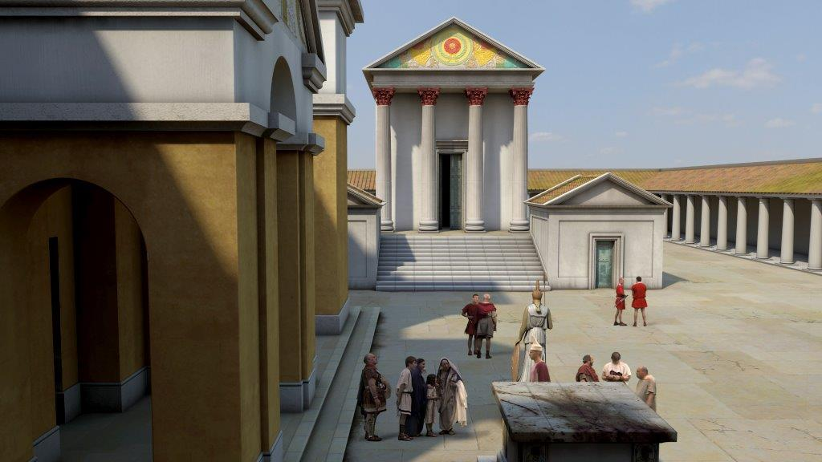

**Minerva’s Head – Thinking Critically**

* **90** What is Minerva’s Head made from? ____________________________

What parts of the statue are missing? _____________________________

Would you have been allowed this close to the statue in Roman times? Why?

_________________________________________________________________

What do YOU think happened to the statue?

__________________________________________________________________________________________________________________________________

Turn the corner and explore the corridor next to the Sacred Spring.

* **80** What kind of objects were thrown into the Sacred Spring?

____________________________________________________________

Draw and label one from the displays.

Find the object made from ivory. What does it show, and what does this tell us about the person who offered it?

**___________________________________________________________________________________________________________________________________________________________________________________________________**

**The Great Bath**

As you explore the Great Bath, be careful of the pavements, they are 2,000 years old!

* **33** What is the Great Bath lined with?______________________________
* **52** What activities might be going on by the bath?

____________________________________________________________________________________________________________________________________________________________________________________­­­­­­­­­­­­­­­­­­­­­­­_____________________

Why is the water green? Would it have looked like this is Roman times?

__________________________________________________________________________________________________________________________________

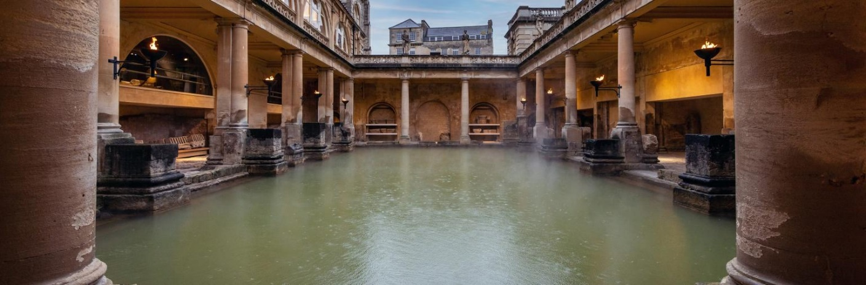

**‘The Baths’ – Written Communication**

You are now back outside ready to complete the final, most exciting part of the trail. Your task is to complete a word bank ready for when you return to school to help you compose a piece of creative writing about the Baths. Complete the table below. The audio commentaries will help you and the first one has been completed for you. Start by turning left into the East Baths and continue in a clockwise direction.

|  |  |  |
| --- | --- | --- |
| Room Name | Latin Meaning | Describing Words |
| Balneum | Deep immersion pool | whole body healing comforting |
| Caldarium **(43)** |  |  |
| Tepidarium **(54)** |  |  |
| Apodyterium |  |  |
| Natatio **(11)** |  |  |
| Gymnasium **(68)** |  |  |
| Laconicum **(51)** | “from Laconia (Sparta)”  A hot dry sweating room |  |
| Frigidarium **(96)** |  |  |

Finally, have a taste of the hot spring water using the paper cups provided. What describing words would you use for this?